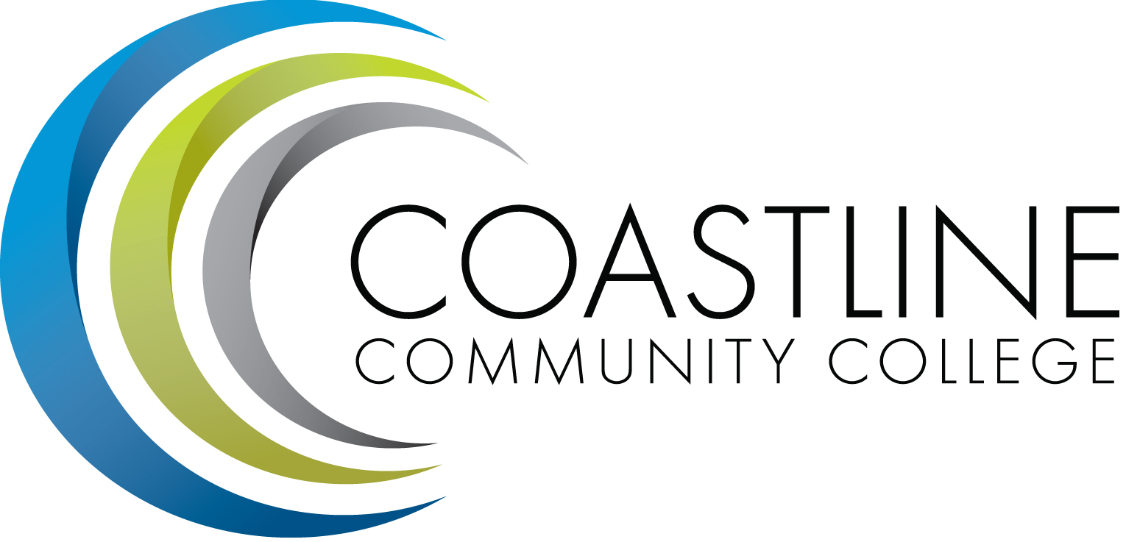
College Council Agenda
June 12, 2018, 9:00-11:00 a.m.
President’s Conference Room, College Center
Committee Mandate: To act on College committee and constituency recommendations, to foster College communication and information sharing, and to review overall College operations.

CALL TO ORDER
  - Welcome
  - Adoption of Agenda
  - Approval of Minutes*:
    - May 22, 2018

SPECIAL REPORTS and UPDATES
  - Constituent Reports
    - Associated Student Government (Jonathan Gomez)
    - Academic Senate (Stephen Barnes)
    - Classified Senate (Kevin Donahue)
  - College Event Calendar:
    - Classified Senate End-of-Year Installation Luncheon, June 21, 2018, College Center
    - Fall 2018 Art Lecture Series - September 19, 26, October 17, 31, November 7 and 14, 2018
    - “Workshops with Carl” (Art) - October 19, 26, November 2, 9, and 16, 2018

ACTION ITEMS
3.1 *Approve Coastline Participatory Governance Philosophy and Procedures

DISCUSSION/INFORMATION ITEMS
- College Council 2018-19 (Goals, Planning)

STANDING REPORTS
  - President and Executive Team Reports – Adrian, Groot, Nguyen, Rodriguez
  - Budget Update (Christine Nguyen)
  - PIEAC (Stephen Barnes/Vince Rodriguez)
  - Program/Department Review (Stephen Barnes/Aeron Zentner)
  - Student Success Committee (Stephen Barnes)
  - Facilities, Safety & Sustainability (FSS) Committee (Christine Nguyen)
  - Technology Committee (Christine Nguyen/Joycelyn Groot)
  - Accreditation (Vince Rodriguez)
  - Financial Aid Federal Program Review (Lori Adrian)
  - Scorecard/Achievement Data (Aeron Zentner)
  - Guided Pathways (Lori Adrian/Aeron Zentner)
  - RSI Task Force Updates (Vince Rodriguez)

ANNOUNCEMENTS

ADJOURNMENT
Next Meeting: August 21, 2018; 9:00 – 11:00 a.m., President’s Conference Room

*Attachment has been emailed.
**Attachment available at meeting.

